Samarth Rural Educational Institute’s
Samarth College of Computer Science, Belhe
Academic Year 2026-2027(SEM-V)
T.Y.B.Sc.(Information Technology)
Practical NO:5
Title : 5.HTML forms and request object
Roll NO: 70 Batch : C

Set A :
Q1. Accept student name and display it.
Ans:

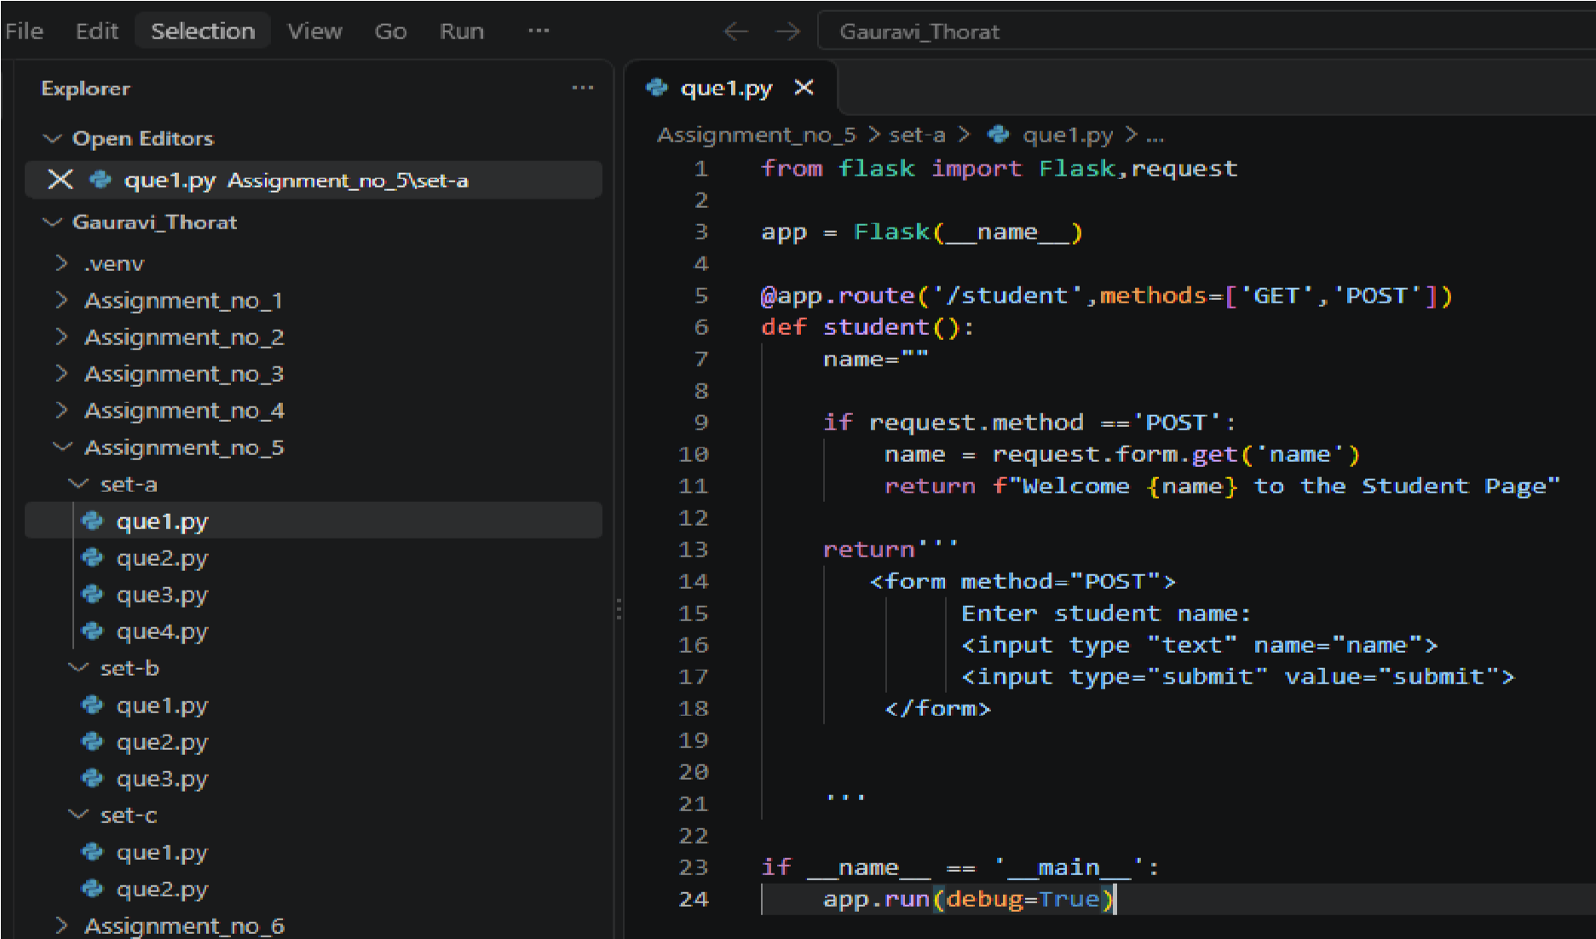
Output:
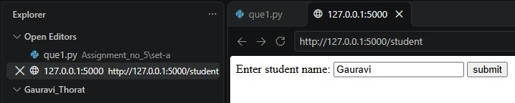
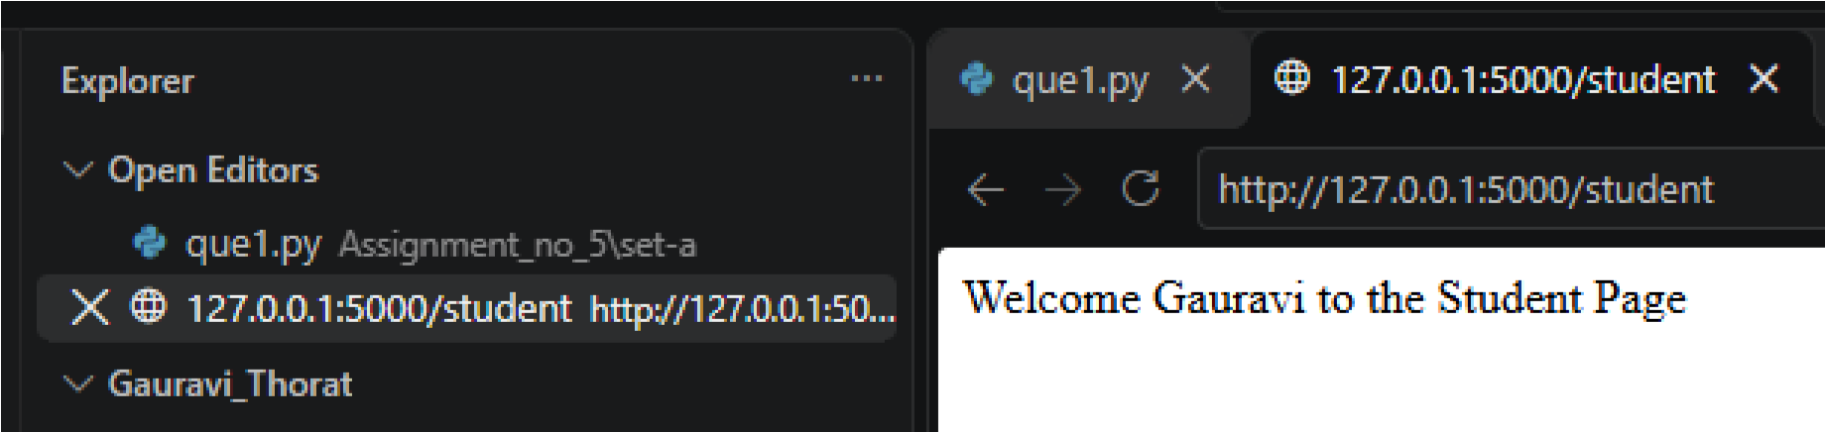

Q2. Accept two numbers and display addition.
Ans:
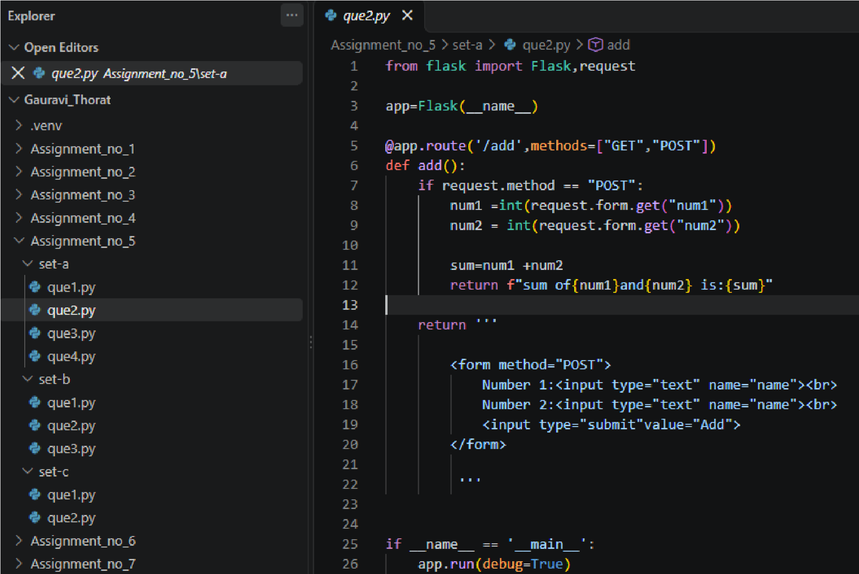
Output:
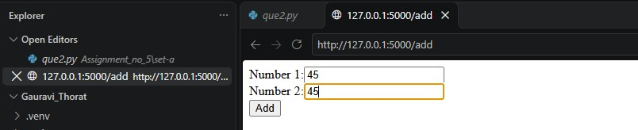
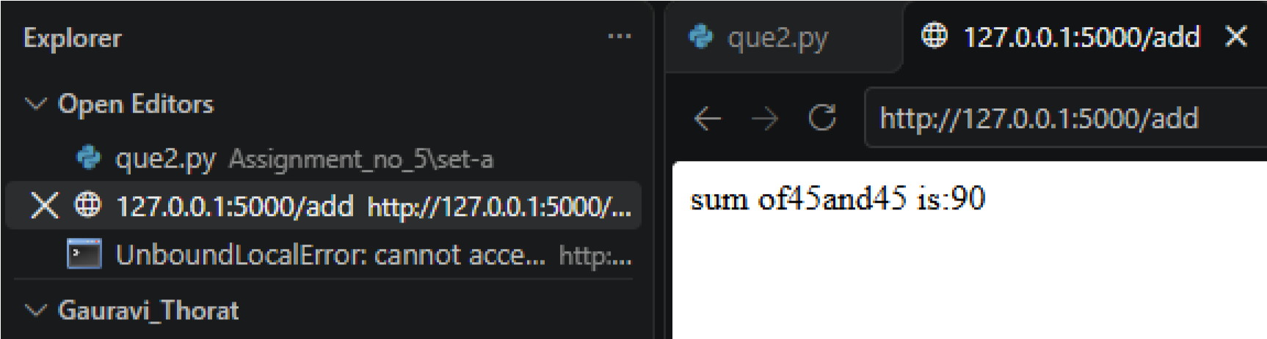
Set B :
Q1. Accept employee details and display entered information.
Ans:
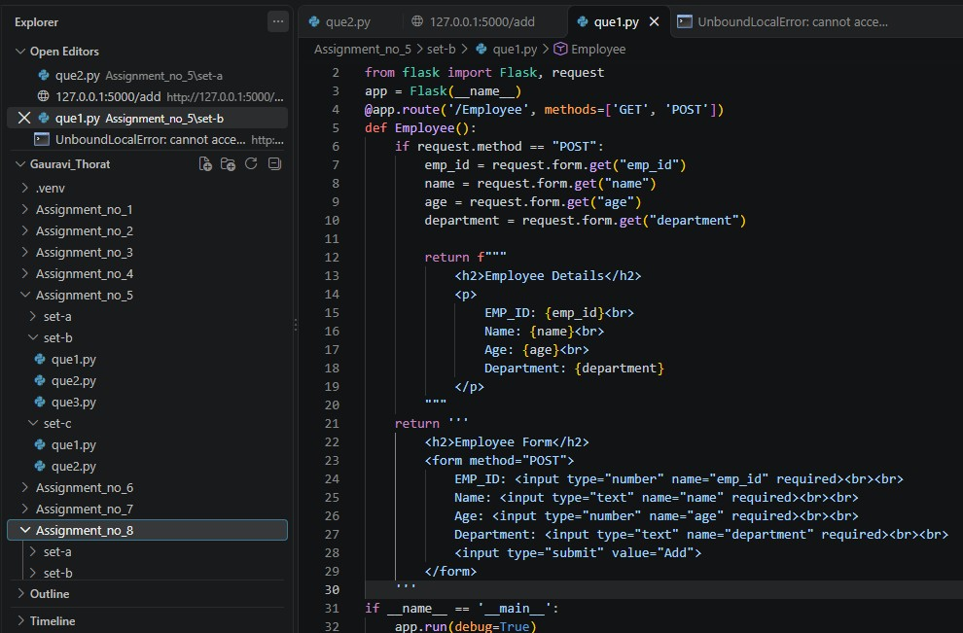
Output:
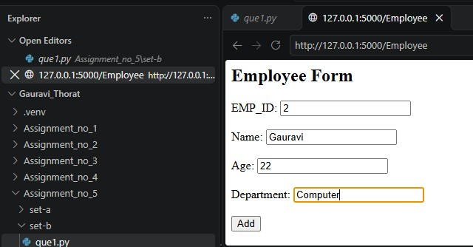
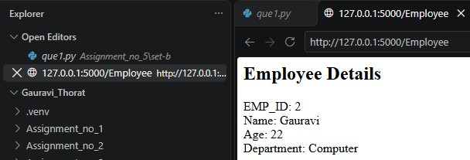

Q2. Accept employee basic salary and calculate the total salary after adding a fixed allowance.
Ans:
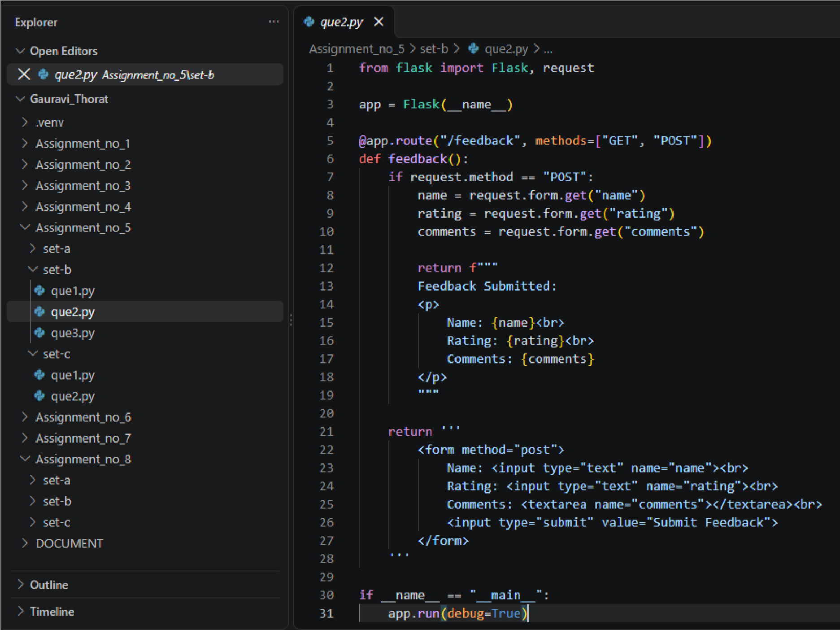
Output:
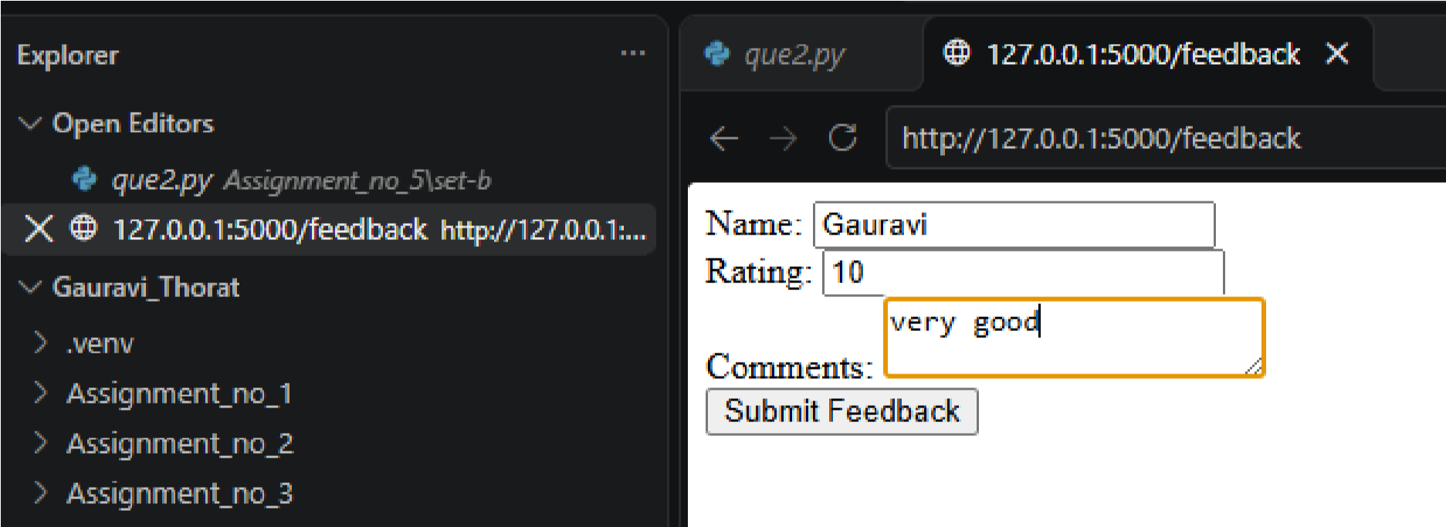
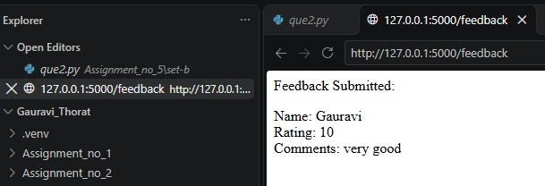

Set C :
Q1. Create a simple login form and validate entered username.
Ans:
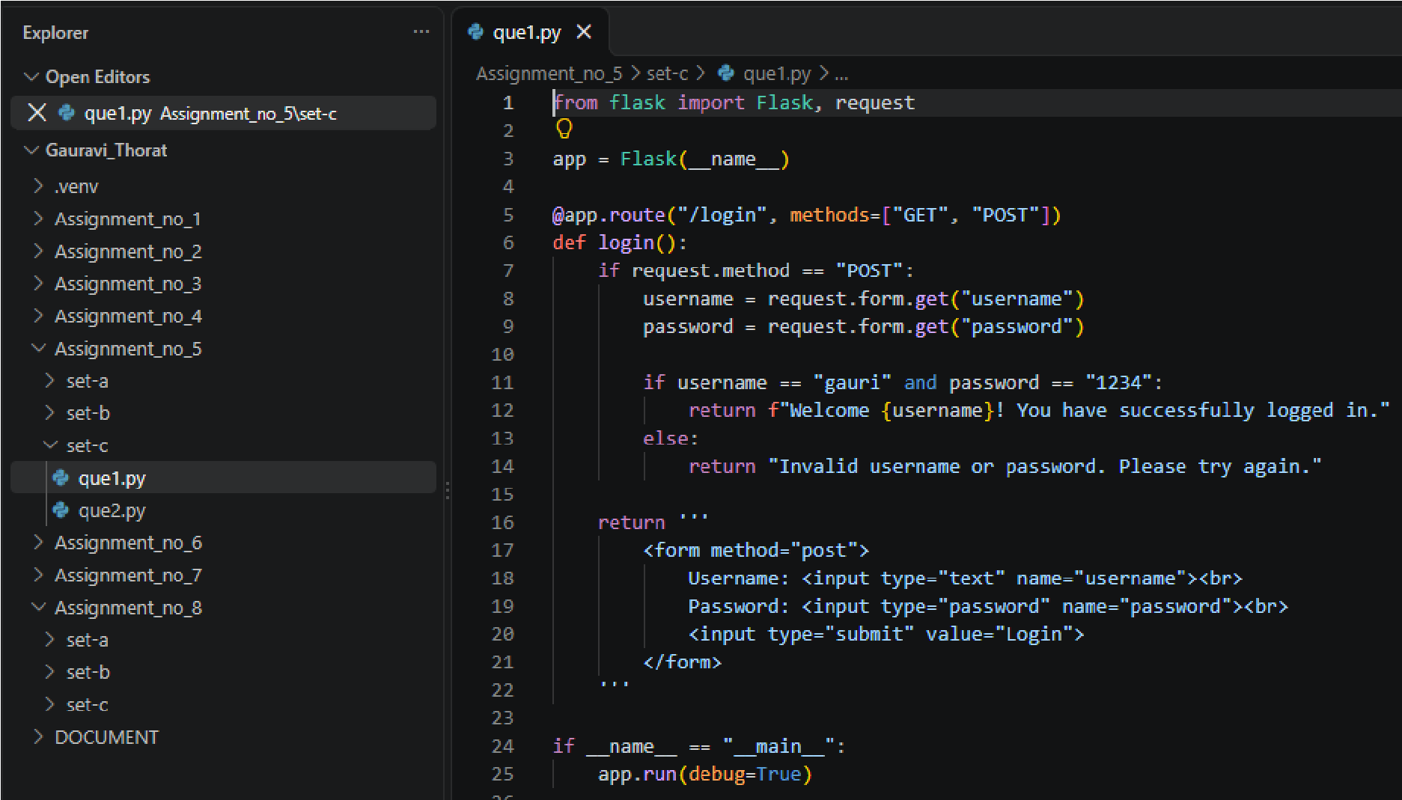
Output:
